Batch: A3 Roll No.: 16010324044
Experiment No.1
Grade: AA / AB / BB / BC / CC / CD /DD

Signature of the Staff In-charge with date

TITLE: Arithmetic operations
AIM: Write an Assembly Language Program of 8086 to :
i) Add two 16 bit no. with carry
ii) Subtract two 16 numbers
iii) Multiplication of two 16 bit no.
iv) Division of two 16 bit no.
(Note: Fetch the data required for arithmetic operation from memory and place the result below data )

OUTCOME:
Student will be able to do all the arithmetic operations and will learn how to access data from memory

Assumptions about data: Before Execution

Addition |  | Subtraction |  | Multiplication |  | Division
Address | Content | Address | Content | Address | Content | Address | Content
1000:2000 | 44 | 1000:2000 | 55 | 1000:2000 | 79 | 1000:2000 | 79
1000:2001 | 44 | 1000:2001 | 55 | 1000:2001 | 1B | 1000:2001 | 1B
1000:2002 | 11 | 1000:2002 | 44 | 1000:2002 | 51 | 1000:2002 | 51
1000:2003 | 11 | 1000:2003 | 44 | 1000:2003 | 21 | 1000:2003 | 21

Program statement: Write a program to add 2 16-bit numbers stored at two consecutive memory locations starting from 12000H. Store the result in the next memory location.

Code:
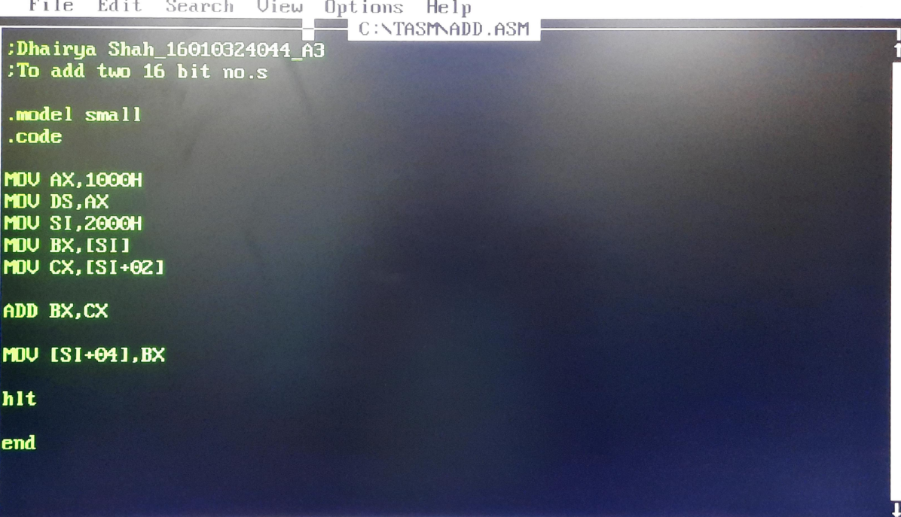

Output:
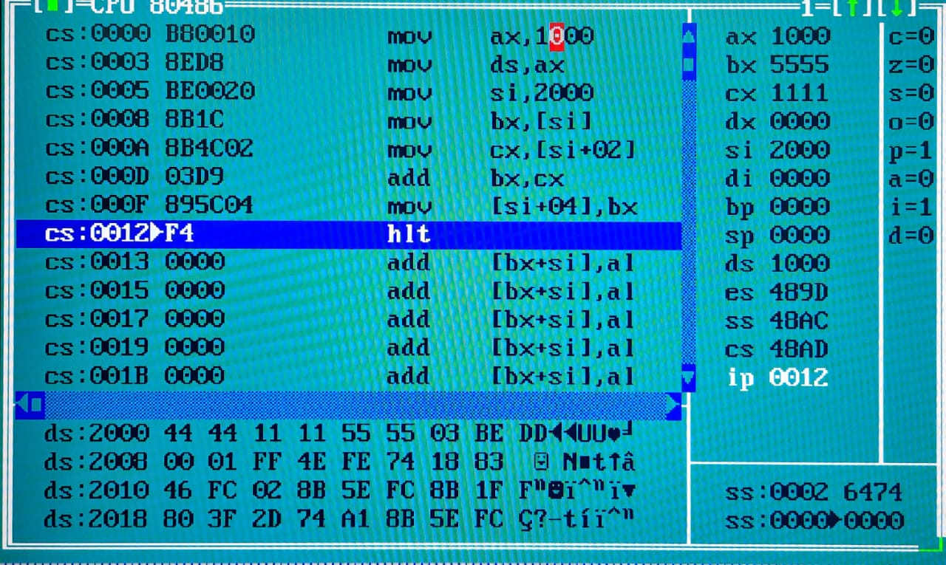

Program statement: Write a program to subtract 2 16-bit numbers stored at two consecutive memory locations starting from 12000H. Store the result in the next memory location.

Code:
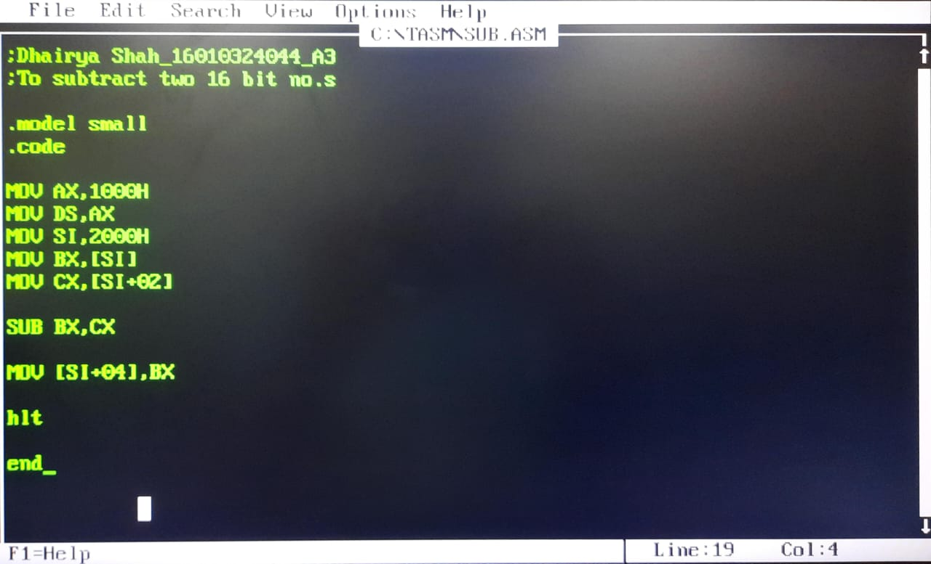

Output:
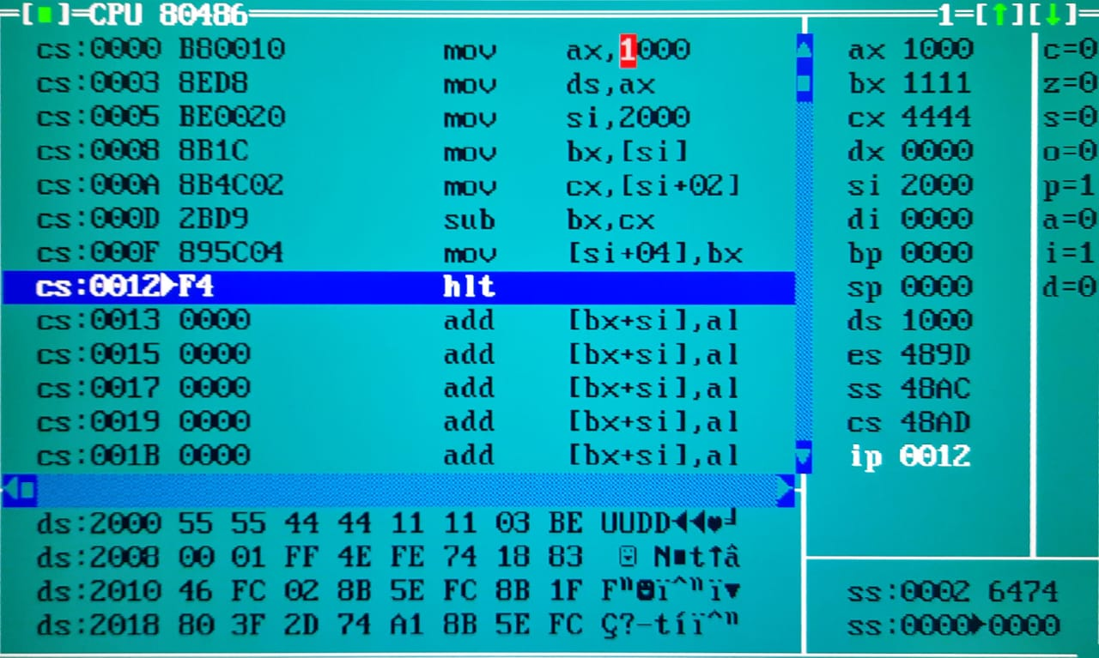

Program statement: Write a program to multiply 2 16-bit numbers stored at two consecutive memory locations starting from 12000H. Store the result in the next memory location.

Code:
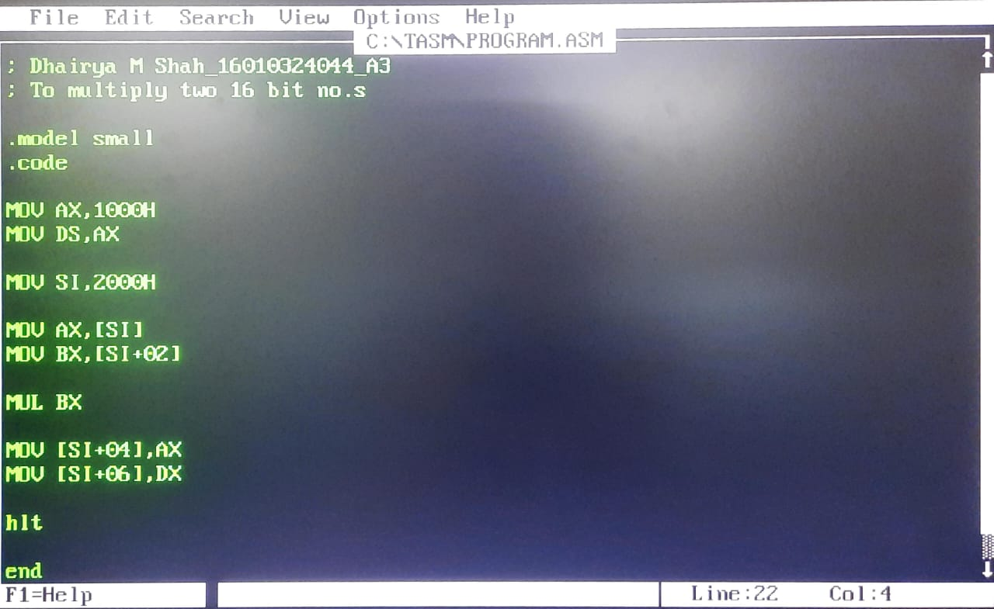

Output:
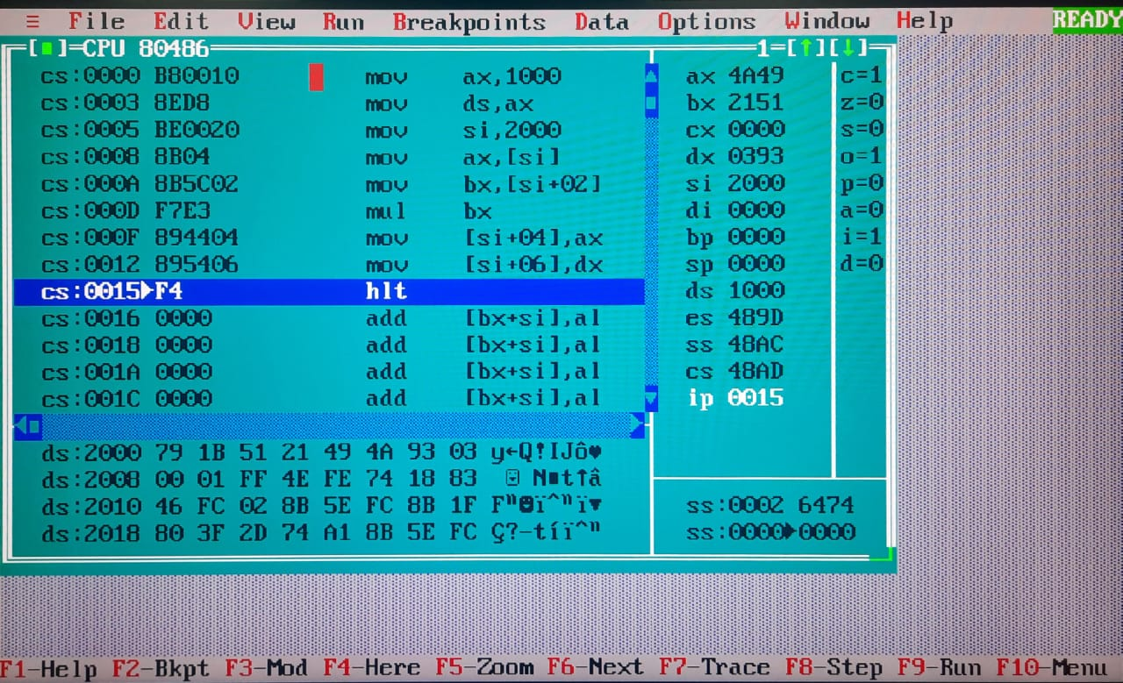

Program statement: Write a program to divide 2 16-bit numbers stored at two consecutive memory locations starting from 12000H. Store the result in the next memory location.

Code:
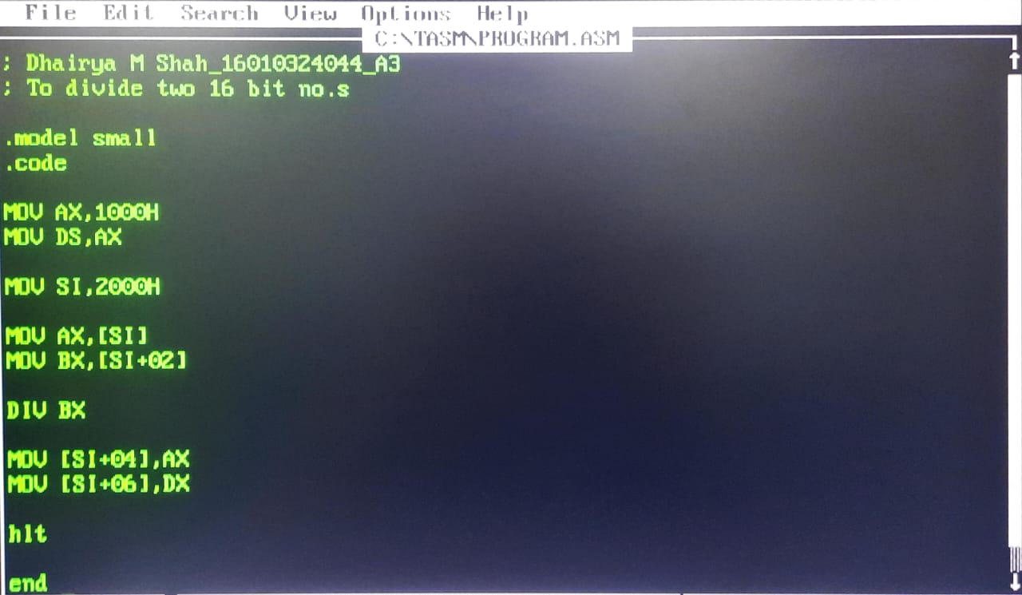

Output:
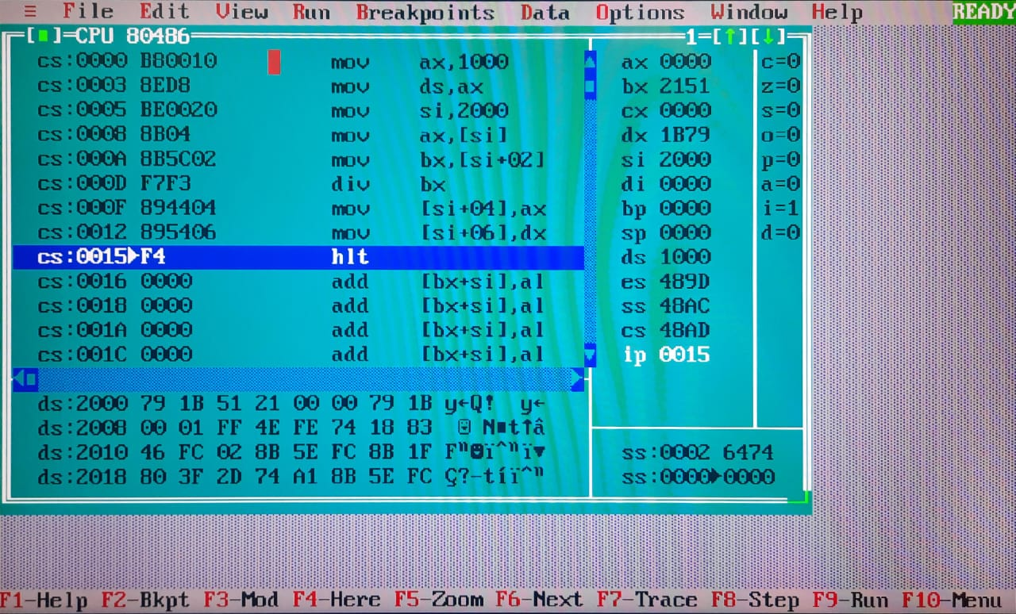

Result:

After Execution

Addition |  | Subtraction |  | Multiplication |  | Division
address | content | address | content | address | content | address | content
1000:2004 | 55 | 1000:2004 | 11 | 1000:2004 | 49 | 1000:2004 | 00
1000:2005 | 55 | 1000:2005 | 11 | 1000:2005 | 4A | 1000:2005 | 00
 |  |  |  | 1000:2006 | 93 | 1000:2006 | 79
 |  |  |  | 1000:2007 | 03 | 1000:2007 | 1B

VERIFICATION OF RESULTS:

Post Lab Questions :

- Explain memory segmentation in 8086.
- In the 8086 microprocessor, memory segmentation is a method used to divide the 1 MB memory into smaller parts called segments. Since the 8086 has only 16-bit registers, it cannot directly access all 1 MB of memory at once.
- To solve this, memory is divided into four segments: Code Segment (CS), Data Segment (DS), Stack Segment (SS), and Extra Segment (ES). Each segment can hold up to 64 KB of data.
- The Code Segment stores program instructions, the Data Segment holds variables, the Stack Segment is used for temporary data during program execution, and the Extra Segment is used for extra data Storage.
- To access a memory location, the 8086 combines a segment address and an offset address using the formula: Physical Address = Segment × 10H + Offset.

- Explain the MOV, ADD , SUB , MUL ,DIV instructions in 8086.
- MOV (Move Instruction)
The MOV instruction is used to transfer data from one location to another.
It can move data between registers, from memory to a register, from a
register to memory, or from an immediate value to a register/memory.
- ADD (Addition Instruction)
The ADD instruction adds the source operand to the destination operand
and stores the result in the destination.
- SUB (Subtraction Instruction)
The SUB instruction subtracts the source operand from the
destination operand and stores the result in the destination.
- MUL (Multiplication)
The MUL instruction performs unsigned multiplication. The result is stored
in AX or DX:AX depending on the size.
If multiplying 8-bit numbers: AL × operand → result in AX
If multiplying 16-bit numbers: AX × operand → result in DX:AX
- DIV (Division)
The DIV instruction performs unsigned division. The result is stored in
quotient and remainder registers.
For 8-bit divisor: AX ÷ operand → quotient in AL, remainder in AH
For 16-bit divisor: DX:AX ÷ operand → quotient in AX, remainder in DX

Conclusion: (specify the concepts learnt in this experiment)

In this experiment, I learnt basic arithmetic operations like addition,
subtraction, multiplication, and division in 8086 Assembly Language. I learned how
to access 16-bit data from memory then perform operations and store results back into
memory. I learnt the concept- memory addressing using segment-offset pairs.

Signature of faculty in-charge

